THE INTERNATIONAL NEBI DANIEL ASSOCIATION

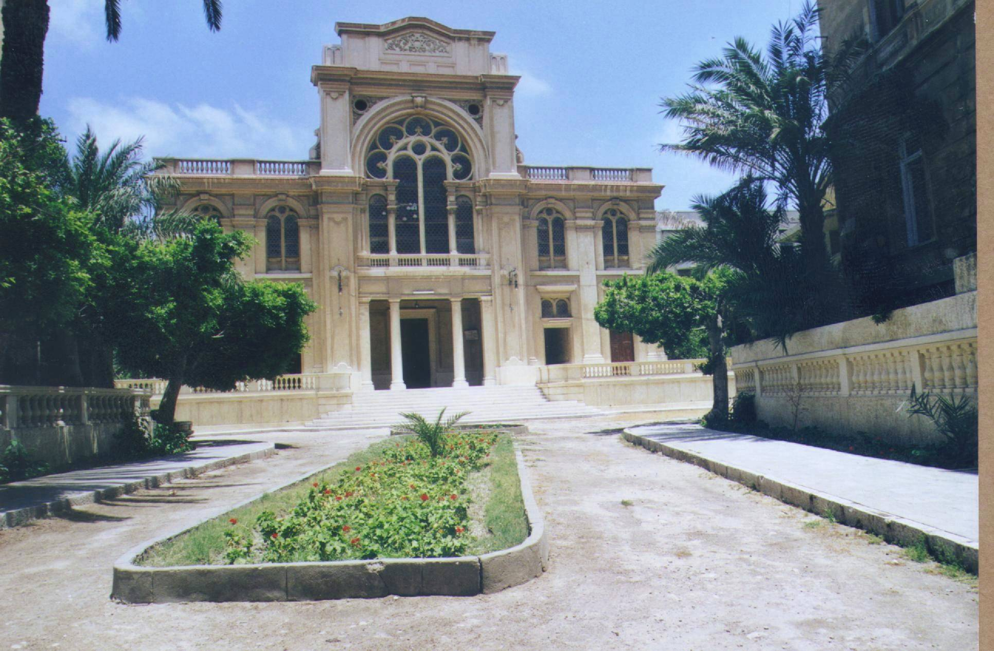

- Name, registered address and objectives

Article 1
The Association’s name is :

The International Nebi Daniel Association. It is a not-for-profit association regulated by the appropriate French Law of 1/07/1901.

Article 2
The Association’s registered office is :

22 Cours Ferdinand de Lesseps, 92500 Rueil Malmaison, France

Article 3
The Association’s objectives are :

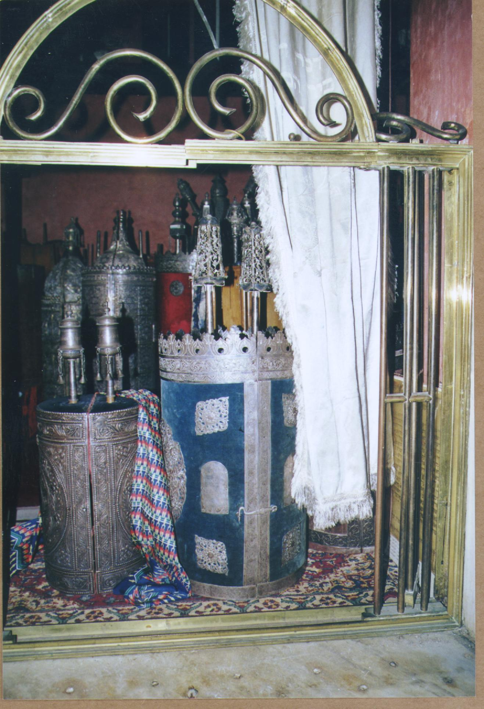
The preservation and continuous management, in accordance with Jewish traditions, of the religious and cultural heritage, the financial and real-estate assets and the civil and religious registers of the Jewish Community of Alexandria and, by extension, the Jewish Community of Egypt.

A. I. N. D.

Members

Article 4
The Association is composed of individuals (Founding Members, Active Members, Supporting Members and Honorary Members) and organisations that qualify (Members by Right).

Article 5
The admission of new Members is subject to the following :

With the exception of the third and fourth group below, all Members must be Jews originating from Egypt or the descendants of Jews originating from Egypt.

- Founding Members : members involved in the formation and administration of the Association prior to the first General Meeting. Each Founder Member has one vote and collectively the Founding Members have an additional 30 votes if Members by Right have joined.
- Active Members : members who have paid their annual subscription. They have a say in all activities of the Association and each Active Member has one vote. They are eligible to be members of the Council.
- Supporting Members : members who have not paid their annual subscription but have expressed their full support of the objectives of the Association. They have a consultative say during Association meetings and in any modification of the objectives of the Association.
- Honorary Members: members that have been approached and co-opted by the Council. They have an advisory role to the Council and provide active support.
- Members by Right : official representatives of national and international associations of Jews from Egypt who subscribe to the objectives of the Association and support its internal constitution. Each Association is entitled to 30 votes.

Members may notify the Association of their resignation through non-renewal of their subscription or in writing to the Association. Members lose all rights upon resignation or death.

The Council can recommend that a Member be struck off after hearing representations from the Member in question and following a decision taken by a two-thirds majority of the Council.

The identity of Members, with the exception of Honorary Members and Members by Right will be kept confidential and will not be divulged without the consent of the individuals concerned.

A. I. N. D.

Article 6
Active Members and Members by Right pay an annual subscription set by the Council.

For the first year, the subscription is set at 50€ per Active Member and at a minimum of 200€ for Members by Right. The Founding Members are called upon initially to contribute significant sums to cover set-up costs. They will subsequently pay a subscription equal to that of Active Members.

The Association can receive donations or income to pursue its objectives. A register of expenditure and receipts will be kept by the treasurer of the Association.

General Meeting

Article 7

General Meetings are constituted by all Active and Founding Members and Members by Right (Supporting Members and Honorary Members can attend only in an advisory capacity).

The functions of the General Meeting include :

- approval of the budget and accounts
- endorsement of the Council’s performance and/or dismissal of existing Council members
- changes to the Articles of Association
- changes to the internal organisation of the Association
- the dissolution of the Association.

Article 8

General Meetings are held under the presidency of the Council every 2 years at a location advised in the notice of the meeting.

Members will be advised of General Meetings by notice sent by letter, fax, electronic mail or any other means of communication, 60 days before the General Meeting which will include an agenda for the meeting.

An Extraordinary General Meeting may be called by the Council where necessary. Notice is given by letter, fax, electronic mail or any other means of communication 20 days before the Extraordinary General Meeting which will include an agenda for the meeting. In addition, Members holding at least 33% of valid votes can call an EGM under the same conditions.

A. I. N. D.

Article 9
Active Members can be represented at the General Meeting by any other Active Member with a proxy. An Active Member cannot hold more than 30 proxies.

A simple majority of Members with voting rights must be present or represented for a valid General Meeting, other than for amendments to the Articles of Association or the dissolution of the Association where Article 11 will apply.

Article 10
Save for exceptional circumstances described in these Articles of Association, resolutions are approved by a simple majority of Active Members or Members by Right who are present or represented. Such resolutions will be notified to all Members.

No item can be voted on unless it is listed on the circulated agenda.

Resolutions of the General Meeting are noted in a register signed by the president, the secretary and the treasurer. The register is held at the registered office and can be viewed by the Members.

The dissolution or liquidation of the Association can be determined by a General Meeting.

In exceptional cases justified by the urgency and special interest of the situation, decisions normally taken at a General Meeting or by the Council can be taken by the unanimous consent of the Council Members by a written resolution which will be sent to each Council Member, accompanied by a note explaining the reason and means by which the decision is to be made. This resolution will be returned and will include the following : the name of the Council Member, his address, the agenda and the vote or abstention to be taken on each of the items on the agenda, as well as the term of the mandate. The notice will be signed. The first General Meeting or Council meeting held after the written resolution will ratify that decision.

Article 11
The dissolution of the Association or modification of the Articles of Association must be proposed by either the Council or at least 30 Active members.

The Council must inform the Members of the Association at least three months in advance of the General Meeting which will consider such modification or dissolution.

A General Meeting cannot dissolve the Association or modify the Articles of Association unless it is consented to by a two-third majority of the Members having the appropriate voting power.

However, if a General Meeting cannot assemble two-thirds of the Active Members of the Association, a new General Meeting will be called under the same conditions to address the same issues. A two-thirds majority of those Members with voting rights present or represented, will then be sufficient.

- I. N. D.

Administration

Article 12
The Association is administered by a Council with a minimum of five and a maximum of nine members. The first Council will be made up of Founding Members until the first General Meeting. The Council will determine the internal organisation of the Association which will be available to Members on request.

The Council can co-opt representatives in different countries and representatives of other associations of Jews from Egypt. A regional representative will be appointed for any region outside Europe that has more than 75 Active Members.

Council Members are co-opted in the first instance by Founding Members and subsequently by the Council. Council Members can be dismissed by the Council or at a General Meeting. If Council Members are dismissed by the Council, an appeal can be made to the General Meeting. Council members are appointed for a renewable term of two years.

If a Council Member can no longer fulfil his duties, a provisional Council Member can be appointed by the Council to complete the term of such Council Member. Council Members can be dismissed at the General Meeting by a simple majority of Members with voting rights present or represented.

Article 13
The Council elects the following officers : a president who ensures that the statutes of the Association are adhered to, a vice-president who, like the president, represents the Association in all its dealings, a secretary who maintains the administrative register of the Association and a treasurer who manages the accounts and assets of the Association.

Article 14
The Council will meet following a request by one of the officers through the secretary. A notice is sent by letter, fax, electronic mail or any means of communication.

A Council Member can be represented by another Council Member. A Council Member may not hold more than three proxies. The Council must have a quorum of at least three members who are present, representing a minimum of five members.

Article 15
Officers have all managerial powers for negotiating and managing, save for the powers belonging to the General Meeting. Day-to-day management can be delegated to the president, a Council Member or a third party. Specific responsibilities and special powers can be conferred to one or more persons. The officers will implement the decisions of the Council and the objectives of the Association.

A. I. N. D.

Article 16
Resolutions of the Council are taken by simple majority of those present or represented. In cases of an equality of votes, the president has the casting vote.

All resolutions will be noted in the register which will be signed by the president and the secretary and kept by the treasurer for consultation by the Members of the Association.

Article 17
All acts that bind the Association, except with special dispensation, have to be signed by three officers of the Association. Third parties are not required to enquire as to the officers’ authority for such acts.

Article 18
In all judicial proceedings to which the Association is a party, it will be represented by the Council, who in turn will be represented by its president or another Council Member designated by him for that purpose.

V. Budgets and Accounts

Article 19
The financial year of the Association ends on 31st March.

The Council is required to submit to the General Meeting for its approval the accounts of the previous years as well as the budget for the following years. The Council can provisionally approve these accounts until the following General Meeting.

The General Meeting can determine to create reserves by fixing a specific contribution from Members towards such reserves.

VI. Miscellaneous

Article 20
Anything not covered by these Articles, and any other mandatory publications will be regulated according to the Law. The Association will request an official status by registering its incorporation at the Préfecture des Hauts de Seine as early as possible.

The French text of these Articles of Association is the original. This English translation is for the benefit of Members who do not speak French. In the event of any dispute on the interpretation of the text the French version will prevail.

A. I. N. D.

FOUNDING MEMBERS

Mr BARUCH, Salomon Retired
Born 08/04/1933 in Alexandria, Egypt
7 Passage Saillenfait, 94000 Creteil, France

Mr BILBOUL, Roger Publisher
Born 31/08/1940 in Alexandria, Egypt
22 Earls Terrace, London W8 6LP, GB

Mr FARHI, Robert Retired
Born 07/03/1929 in Cairo, Egypt
65 rue St Didier, 75116 Paris, France

Mr FEDIDA, Yves Consultant
Born 05/08/1945 in Alexandria, Egypt
110 Hendon Lane, London N3 3SU, GB

Mr NACAMULI, Alec Engineer
Born 22/08/1943 in Alexandria, Egypt
15A Hendon Avenue, London N3 1UL, GB

